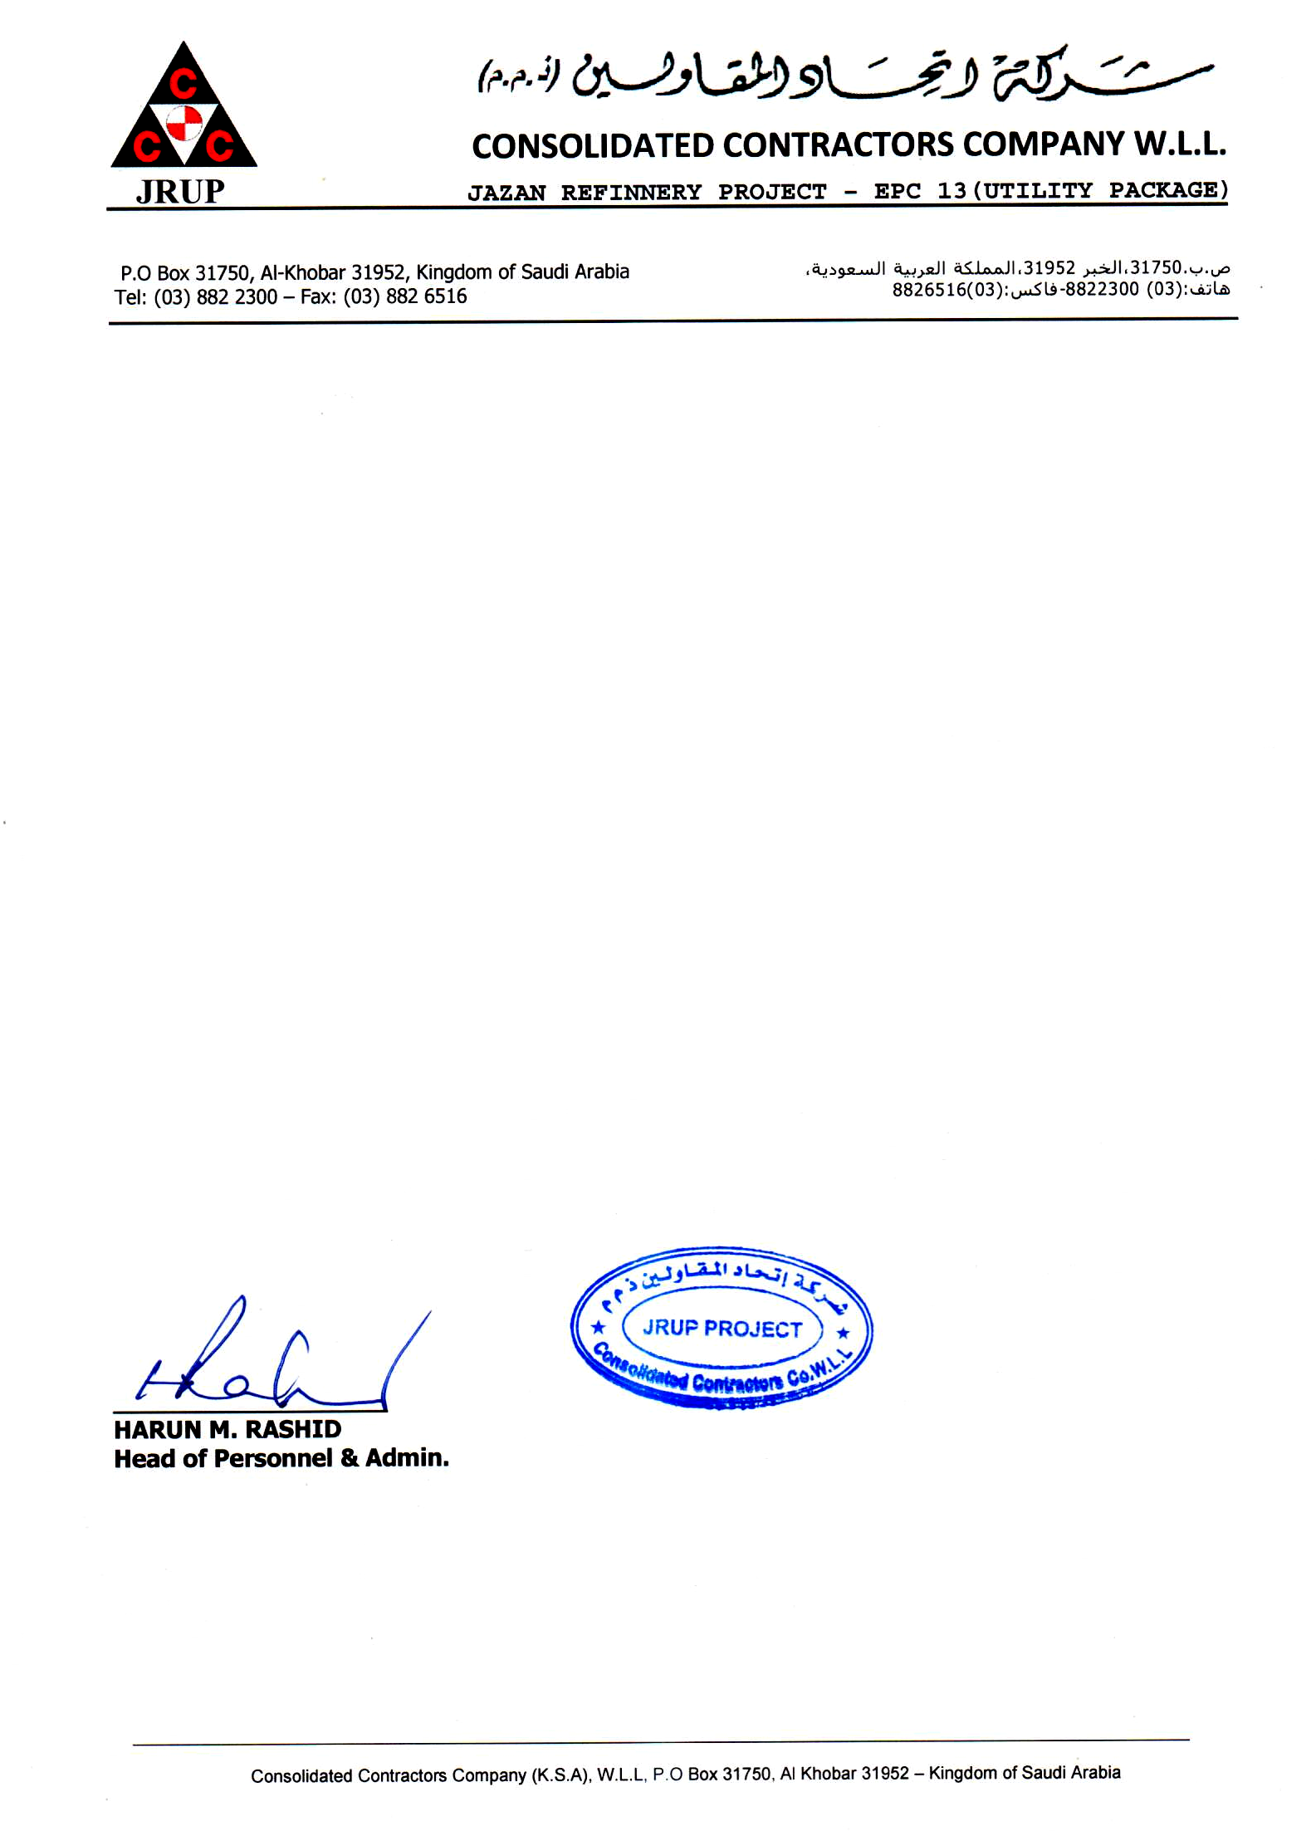

Date: <To> Ref: ADM/018/JRUP/***159143***

TO WHOM IT MAY CONCERN

This is to certify that Mr. <Name> Pakistan Nationality Holding Passport No. <Passport> was working with CCC a JRUP Project from <From> Up to his release date on <To> in the Capacity of <Designation>.

This certificate is given to him upon his request without any obligation towards the company.

For Consolidated Contractors Company W.L.L.